GNS3 images

Download ASA image

<https://drive.google.com/file/d/1JdEjOlGXxBjiRZbbrQrXXAzzbvirtiRv/view>

<https://drive.google.com/file/d/18Ly20TlEW5Axk1irl57wYQxl0PCnAFk7/view>

install steps here

<https://www.youtube.com/watch?v=ueA_zFyyS48>

Router image

c7200-adventerprisek9-mz.152-4.S7.image

<https://drive.google.com/file/d/1ATASM6fOq8gSDYTtrIdoC0TttbazxIAY/view?usp=drive_link>

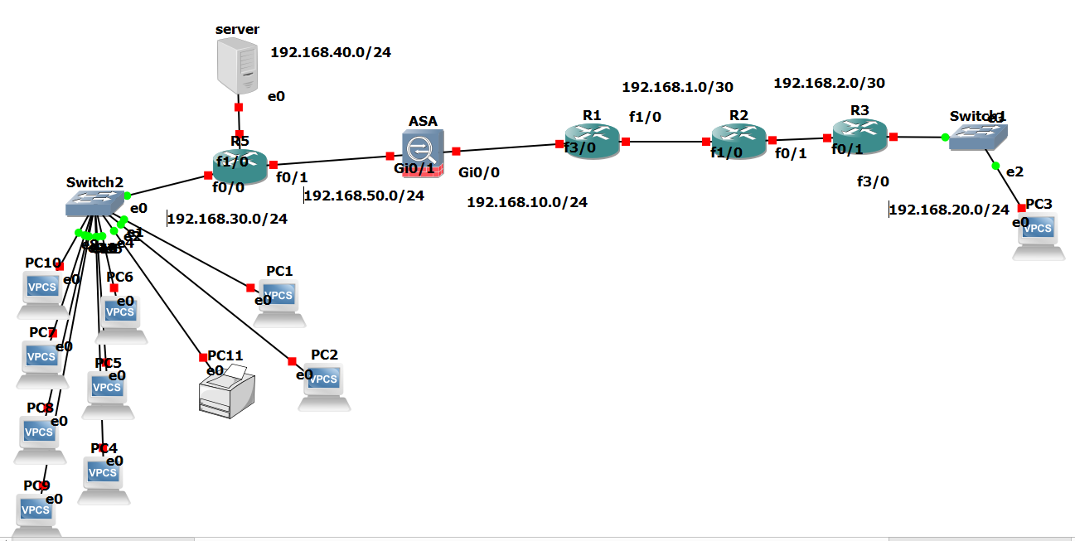

# **Router AS DHCP**

|  |
| --- |
| R5 (config)# interface f0/0  R5 (config-if)# no shutdown  R5 (config-if)# ip address 192.168.30.1 255.255.255.0  R5(config)#ip dhcp pool inside  R5(dhcp-config)#network 192.168.30.0 255.255.255.0  R5(dhcp-config)#default-router 192.168.30.1  R5(dhcp-config)#domain-name learncisco.net  R5(dhcp-config)#dns-server 192.168.30.89 192.168.30.90  R5 (config)# interface f0/1  R5 (config-if)# no shutdown  R5 (config-if)# ip address 192.168.50.1 255.255.255.0  R5 (config)# interface f1/0  R5 (config-if)# no shutdown  R5 (config-if)# ip address 192.168.40.2 255.255.255.0 |

VPC > ip dhcp

|  |
| --- |
| R5 # show ip dhcp binding |

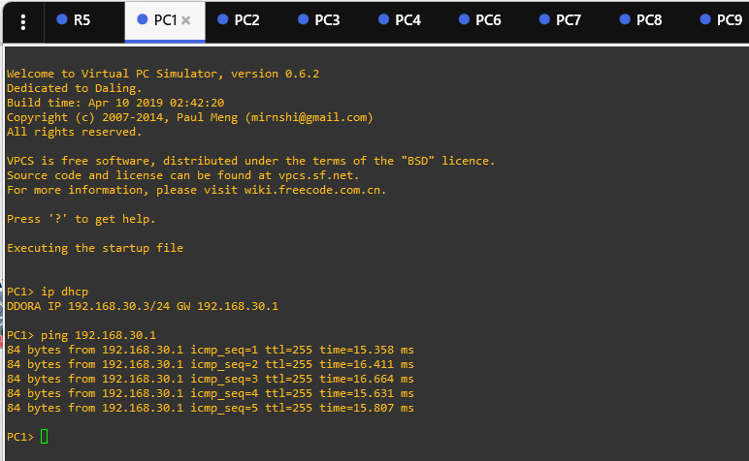

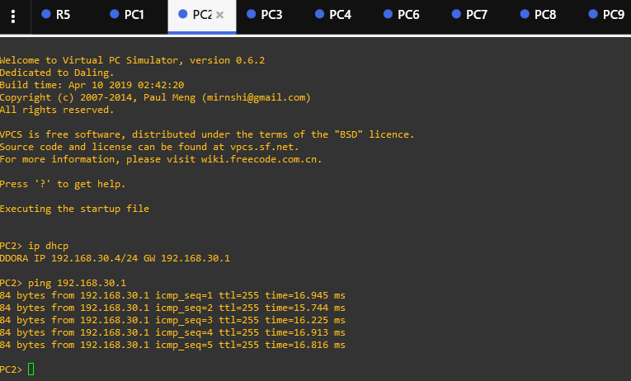

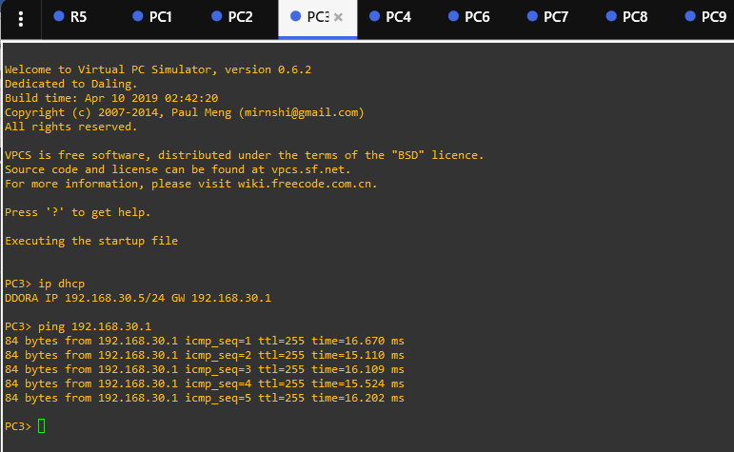

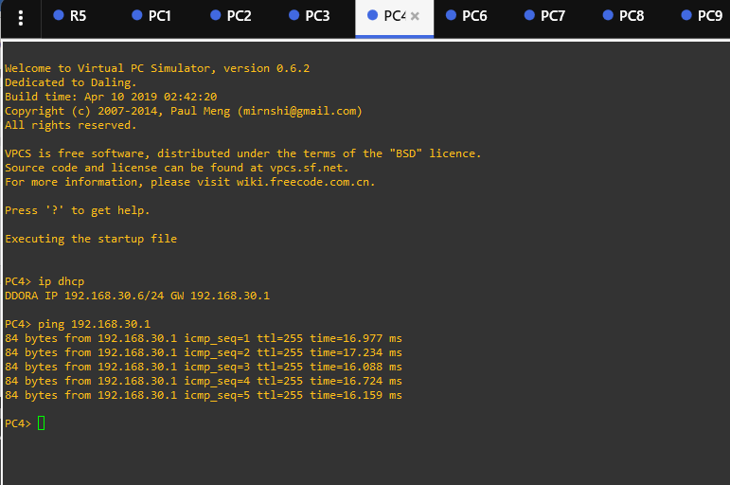

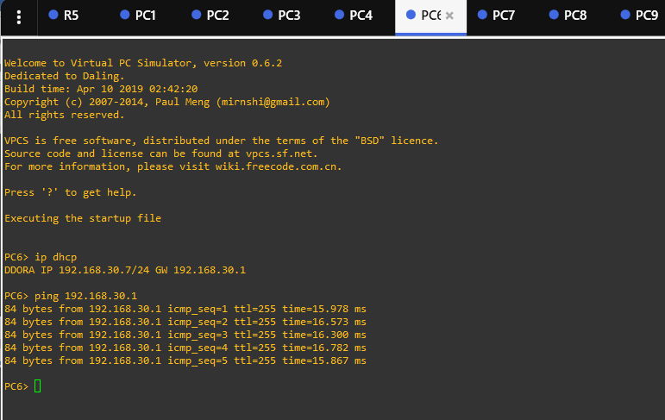

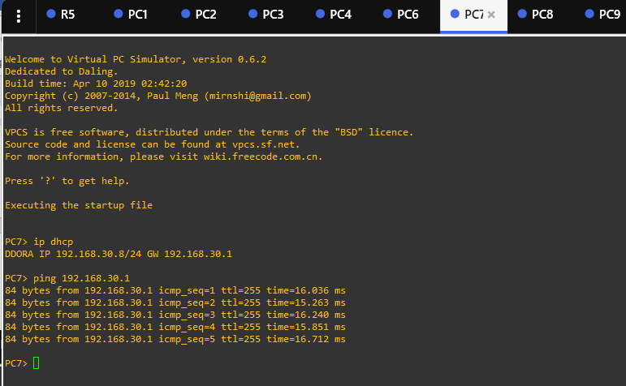

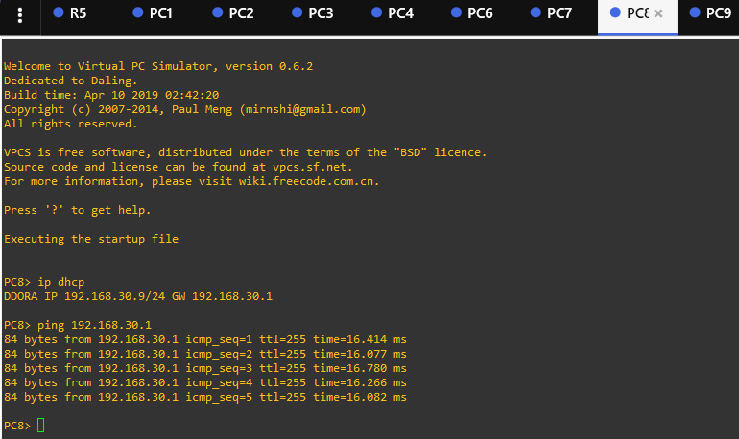

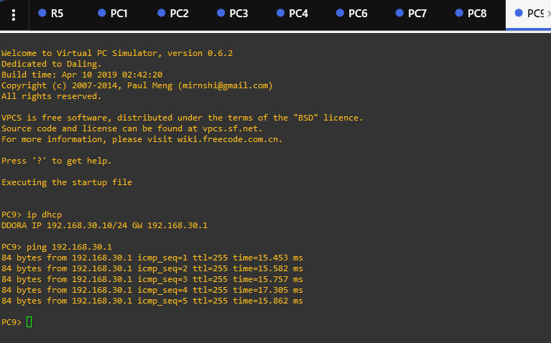

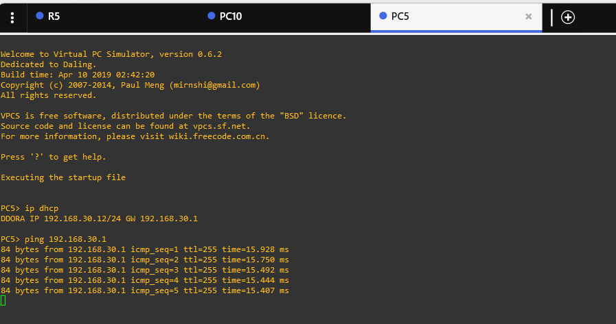

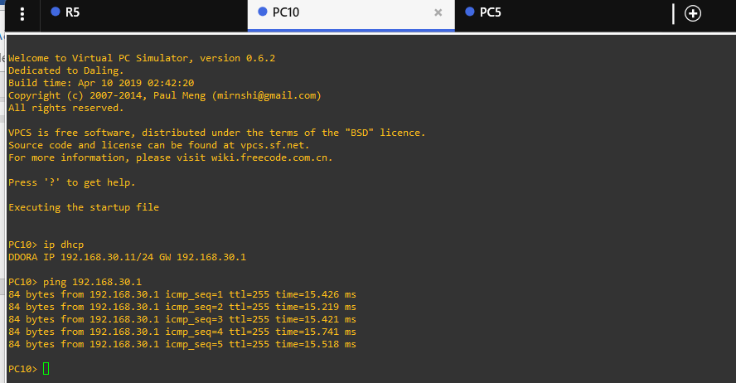

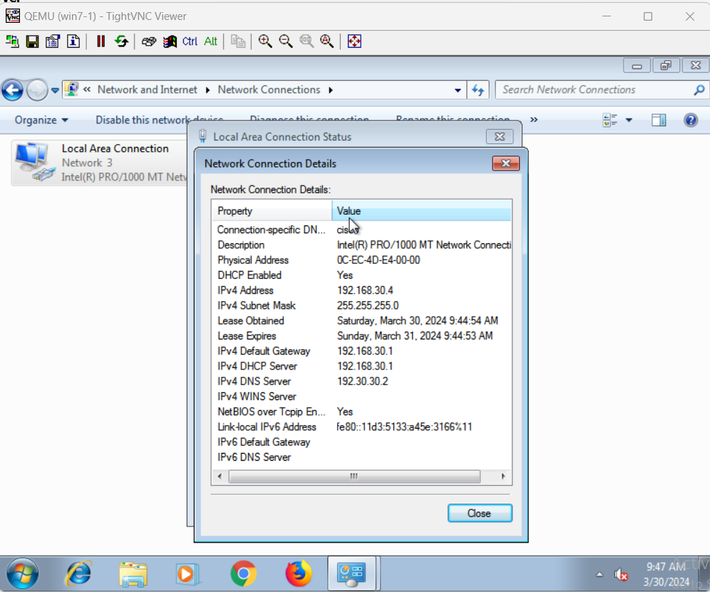

# **R1 as DNS**

|  |
| --- |
| R5 # **configure terminal** R5 (config)# **ip dns server**  R5 (config)# **ip domain lookup**  R5 (config)# **ip name-server 192.168.30.1**  **R5(config)#ip domain-name cisco.com** R5 (config)# **ip host PC1. cisco.com 192.168.30.3**  R5 (config)# **ip host PC2 .cisco.com 192.168.30.4**  R5 (config)# **ip host PC3 .cisco.com 192.168.30.5**  R5 (config)# **ip host PC4 .cisco.com 192.168.30.6**  R5 (config)# **ip host PC5 .cisco.com 192.168.30.7**  R5 (config)# **ip host PC6 .cisco.com 192.168.30.8**  R5 (config)# **ip host PC7 .cisco.com 192.168.30.9**  R5 (config)# **ip host PC8 .cisco.com 192.168.30.10**  R5 (config)# **ip host PC9 .cisco.com 192.168.30.11**  R5 (config)# **ip host PC10 .cisco.com 192.168.30.12**  R5 (config)# **ip host printer .cisco.com 192.168.30.21**  R5# **show hosts**  R5 # **copy running-config startup-config** |

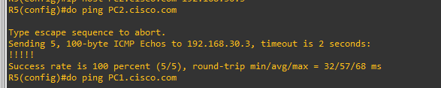

# **ASA configuration**

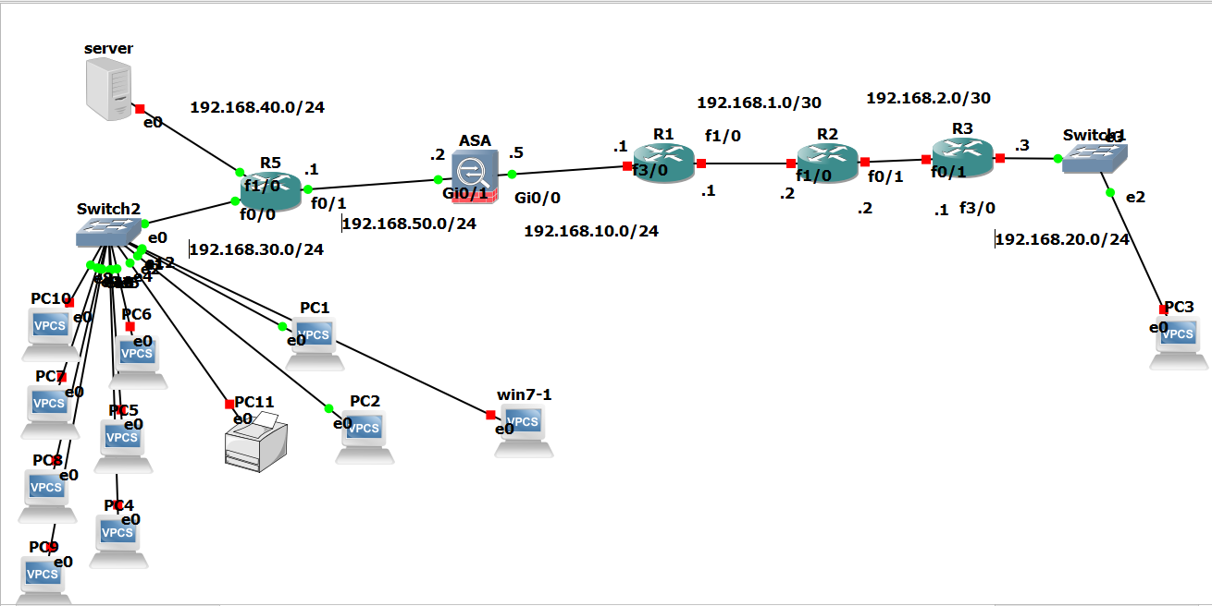

|  |
| --- |
| !  *conf t*  !  *interface GigabitEthernet0/1*  *nameif inside*  *security-level 100*  *ip address 192.168.50.2 255.255.255.0*  !  *interface GigabitEthernet0/0*  *nameif outside*  *security-level 0*  *ip address 192.168.10.5 255.255.255.0*  ! |

|  |
| --- |
| !  object network lan-corp  subnet 192.168.30.0 255.255.255.0  nat (inside,outside) dynamic interface  object network mgmt  subnet 192.168.40.0 255.255.255.0  nat (inside,outside) dynamic interface  !  !  *route outside 0.0.0.0 0.0.0.0 192.168.10.1*  *route inside 192.168.40.0 255.255.255.0 192.168.50.1*  *route inside 192.168.30.0 255.255.255.0 192.168.50.1*  !  *policy-map global_policy*  *class inspection_default*  *inspect icmp*  ! |

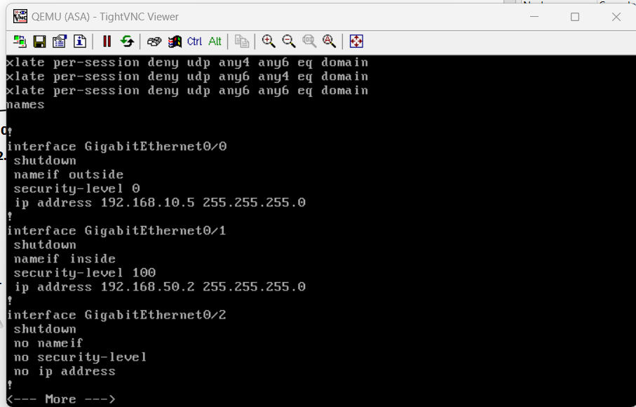

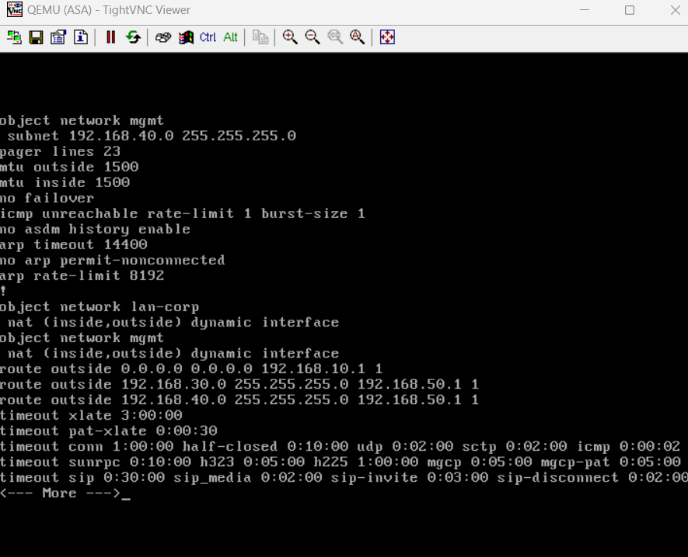

|  |
| --- |
| access-list inside extended permit icmp any any  access-list OUTSIDE extended permit icmp any any  access-group inside in interface inside |

### Step 4: Configure DHCP service on the ASA

|  |
| --- |
| dhcpd address 192.168.50.3-192.168.50.250 inside  dhcpd dns 192.168.30.1  dhcpd lease 3600  dhcpd ping_timeout 50  dhcpd enable inside  dhcprelay timeout 60 |

# **IPSEC VPN configuration (R1 <> R3)**

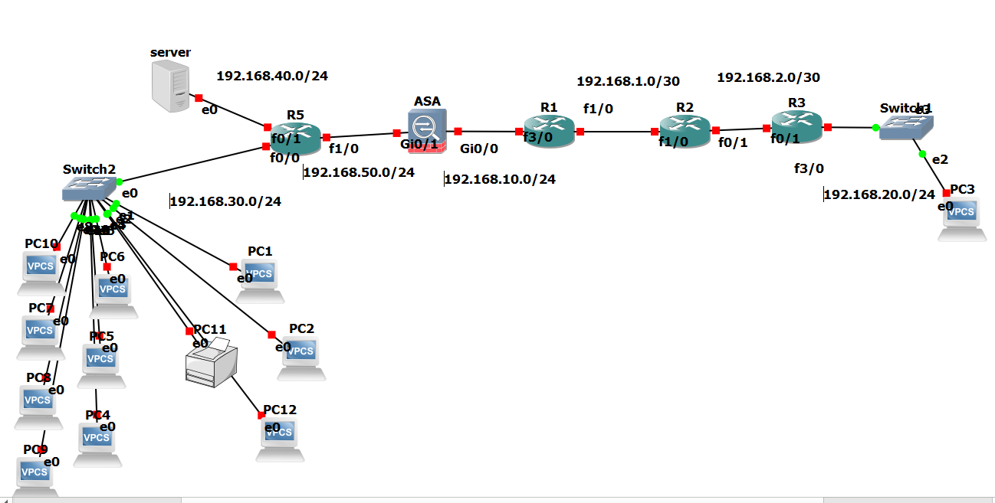

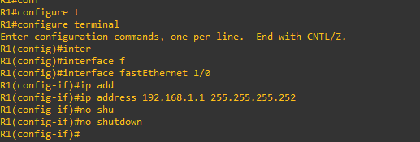

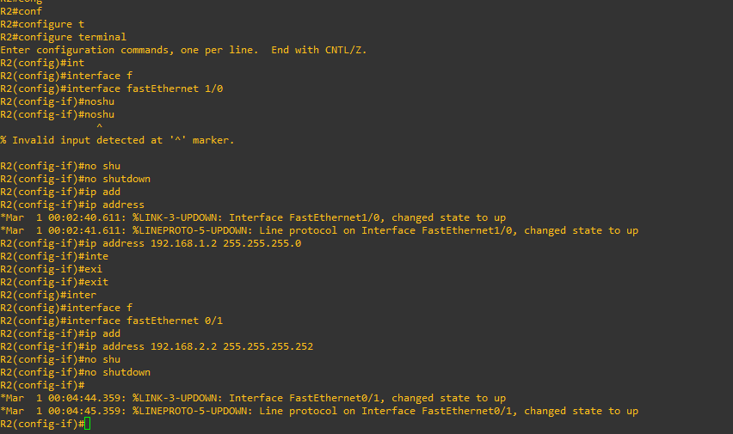

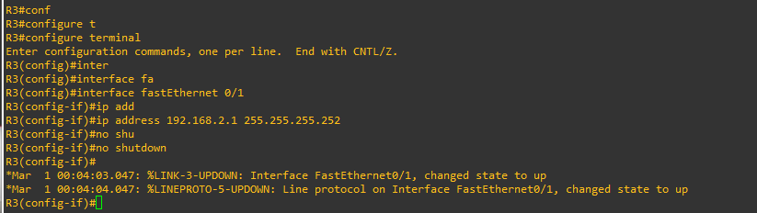





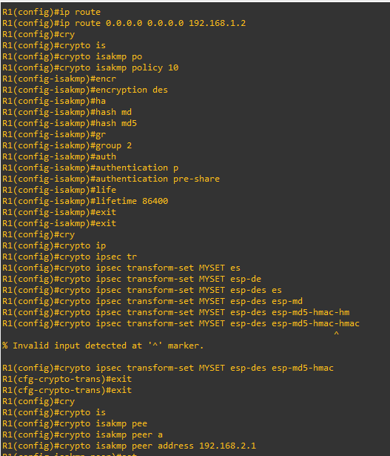

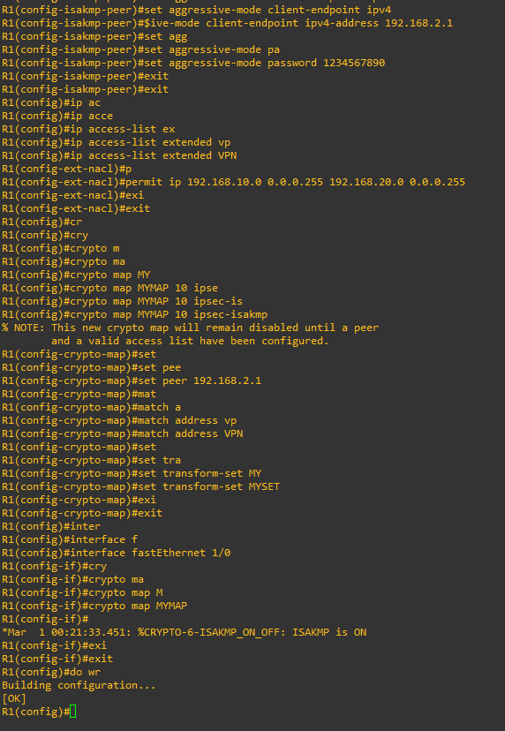

R1# show running config

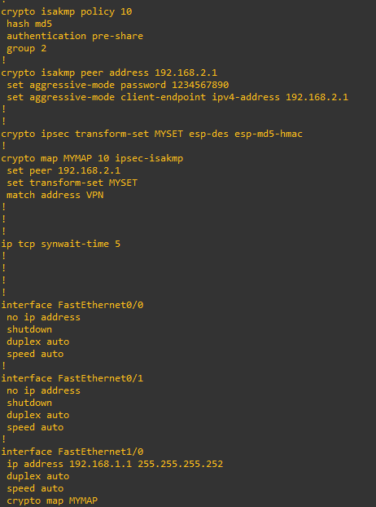

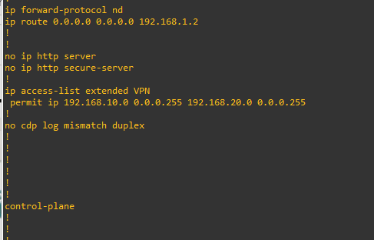

R3 configuration

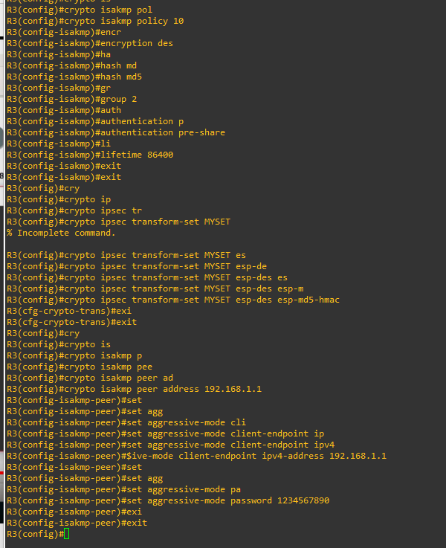

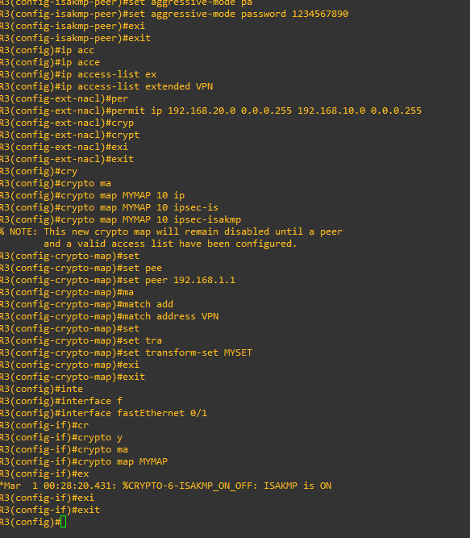

R3# show running config

